Linux directory
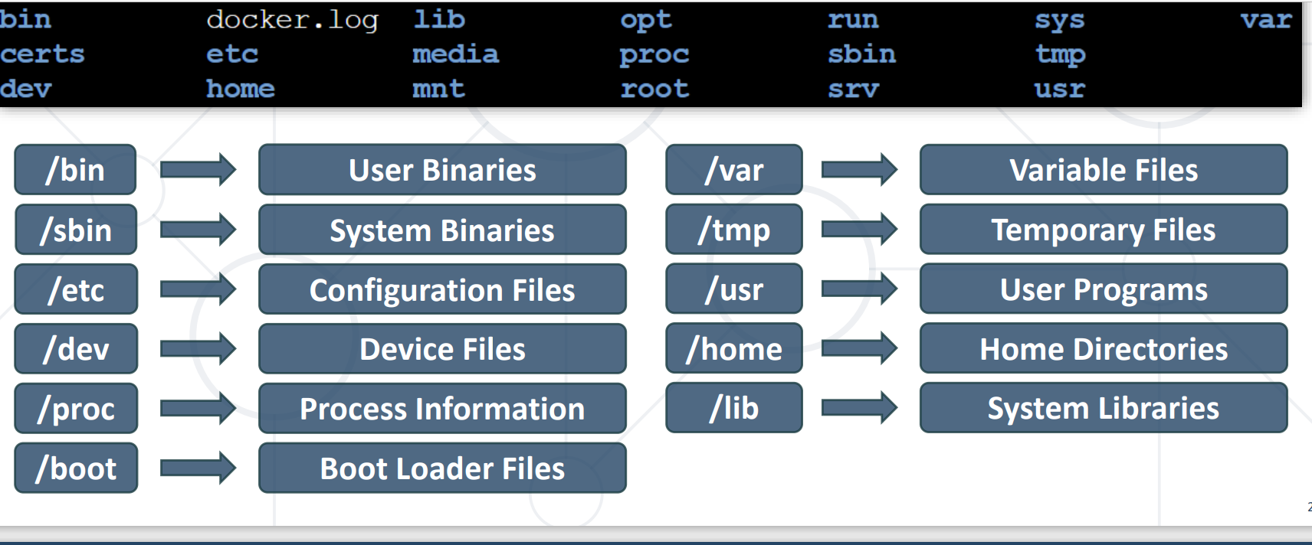
Sleep comand
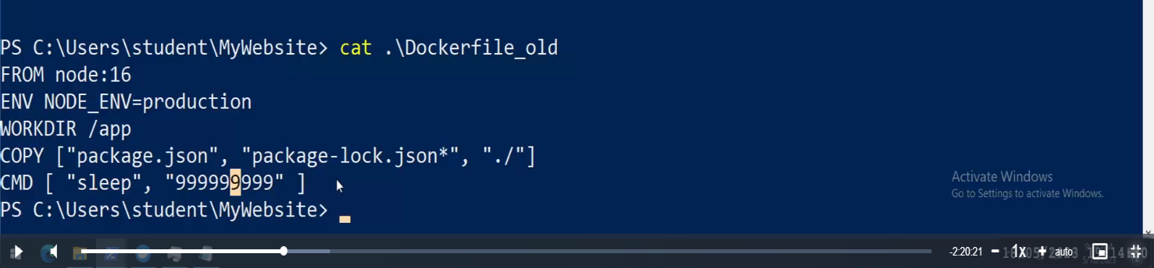
Push to docker hub
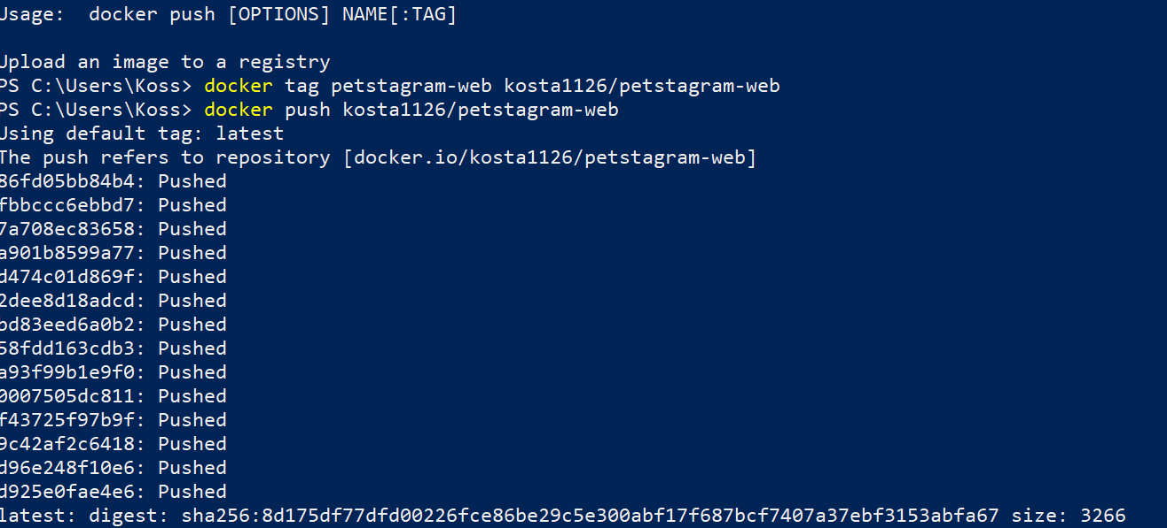
Create network

Windows dir is \
Conect client-container to server-container
First step go inside client-container with
docker exec -it mariadb_client /bin/bash
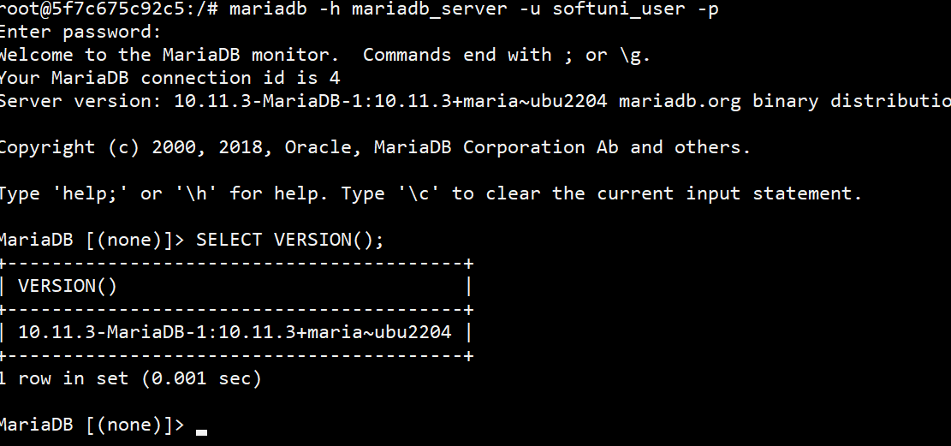

mariadb is application
-h host som you wont conect
-u username
-p password

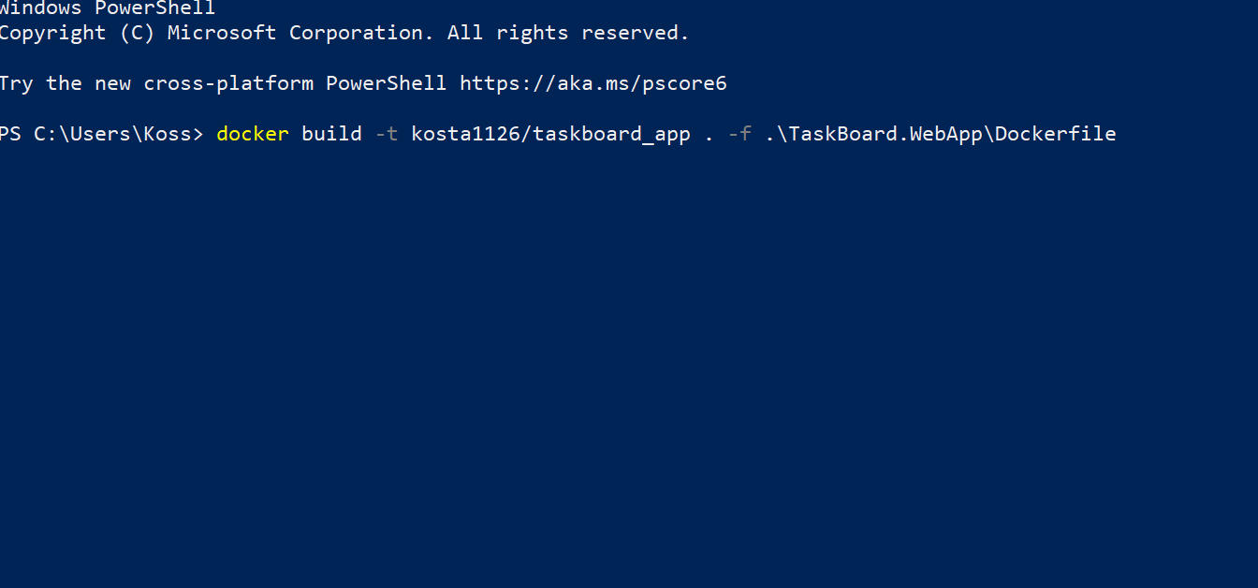
make image from docker file and taged for docker hub

тага и името на файла за докер хъб

това текущата директория от
която ще се копират файловете

това е директорията с докер файла

docker compose down removed containers, volumes and networks
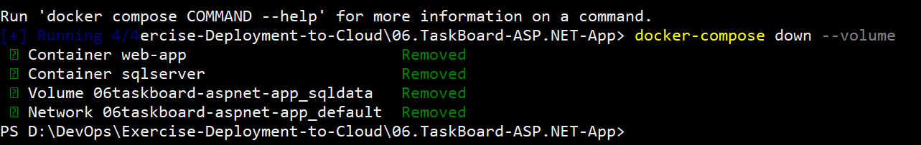

Create container an use volumes from another container
docker create --volumes-from postgres123 --name new_postgres -e POSTGRES_PASSWORD=1123QwER `
>> -e POSTGRES_DB=Blog_db -e POSTGRES_USER=postgres -p 5432:5432 -e PGDATA=/var/lib/postgresql/data/pgdata postgres

